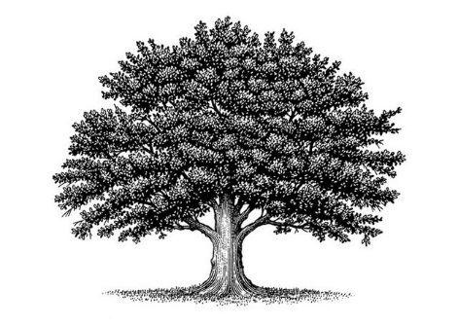
Deed of Land Recording [Your Baby’s Registered Mail Number]
American Common Law Copyright and Trademark of Trade Name

On the ___ day of __________ in the year ________ Anno Domini at the hour and minute of _________ a.m./p.m., a new baby was born on the land of _________________ County in the _____________________State to the __________________Family and was given the name: _______________________________________.

The private natural biological parents are: __________________________________, Father, born ___________on the land of the ________________________County in the ___________________State or foreign country:_____________________& _______________________________, Mother, born
___________on the land of the ______________________County in the ___________________State or foreign country:_________________________.

The family lives in the ________________________County of the ____________________State near ____________________________ and keeps the mailing address: __________________________
___________________________________________________________________________________.
This baby is their ________ living child and ______________ son or daughter (please circle one).

Witness Jurat
In Witness of these facts, before me, a Public Notary, appeared _______________________________ a private natural person and did present proofs of their identity and was deposed and did swear to or affirm these facts from Without the United States and did proclaim them under penalty of perjury and did sign this Deed in confirmation of all the above:
By:_________________________________Witness
By:_________________________________Notary Seal
My commission expires on:___________________.

[EXAMPLE OF HOW A FINISHED –except for autographs-- DOCUMENT LOOKS]
Deed of Land Recording: 5 MKO 2 49987 USA
American Common Law Copyright and Trademark of Trade Name
Genevieve Clementine Martin

On the 14th day of May in the year 2017 Anno Domini at the hour and minute of 10:05 a.m., a new baby was born on the land of Jackson County in the Wisconsin State to the Martin Family and was given the name: Genevieve Clementine Martin.

The private natural biological parents are: Scott LeBrand Martin, Father, born November 6, 1985, on the land of the Wahatchee County in the Idaho State & Jeanine Lucille (Morgan) Martin, Mother, born April 6, 1990, on the land of the Hillsboro County in the Maine State.

The family lives in the Jackson County of the Wisconsin State near Black River Falls, Wisconsin, and keeps the mailing address: c/o 17789 Highway 12, Black River Falls, Wisconsin, 54615.
.
This baby is their second living child and first daughter.

Witness Jurat
In Witness of these facts, before me, a Public Notary, appeared _______________________________ a private natural person and did present proofs of their identity and was deposed and did swear to or affirm these facts from Without the United States and did proclaim them under penalty of perjury and did sign this Deed in confirmation of all the above:
By:_________________________________Witness
By:_________________________________Notary Seal
My commission expires on:___________________.

